2024 GJCL Academic Decathlon CONTEST CODE: 999

VOCABULARY
Define the following:
- Pācō a. soothe b. forage c. barter d. negotiate
- Amictus a. friend b. robe c. spice d. removal
- Vincio a. conquer b. pick c. bind d. make green
- Cervīx a. deer b. hill c. curl d. neck
- Rēmex a. mixture b. rower c. mildly d. hindrance
- Obruō a. test b. sink c. gnaw d. creep
- Sortior a. divide b. luckier c. preserve d shrewmouse
- Trucīdō a. slaughter b. trophy c. pike d. bowl
- Interitus a. inner b. meawhile c. forbid d. ruin
- Praedō a. plunder b. donate c. rich d. pirate

GRAMMAR
Select the Latin word which best replaces the CAPITALIZED word
- Si Hannibal Romam oppugnavisset, urbs CECIDISSET.
- had fallen b. would fall c. would have fallen d. fell
- When infinitives are used as nouns, what is their gender? (1 point)
- masculine b. none of these c. neuter d. feminine
- AFTER THE SPEECH WAS DELIVERED, Hortensius felt encouraged.
- Orationem habituram b. Orationem habere c. Oratio habita d. Oratione habita
- CUM tempestas esset magna, nautae tamen ad portum Carthaginis profecti sunt.
- Although b. When c. With d. While
- NOS SEQUEMUR te ad fines orbis terrarum!
- we are followed b. we have followed c. we shall follow d. we are following
- Hannibal did not think that THE MEN AND ANIMALS would have such hardships on the Alpine crossing.
- viris animalibusque b. viros animaliaque c. virorum animaliumque d. viri animaliaque
- Scimus urbem non uno die CONSTRUCTUM ESSE. (1 point)
- must not be built b. did not build c. will not be built d. was not built
- Verbs of lacking typically take which case?
- accusative b. ablative c. dative d. genitive
- What is the dative singular of the word GENU, meaning knee?
a. genibus b. genui c. genu d. genua
20. Antonius Cleopatraque ultimos dies ALEXANDRIAE egerunt.
a. from Alexandria b. at Alexandria c. for Alexandria d. by Alexandria

DERIVATIVES
Define the CAPITALIZED word:

21. VACCILATE:
A) To dehydrate
B) To hesitate or waver in making a decision
C) To provoke or generate
D) To speak briefly and to the point
22. DESSICANT:
A) A person who is stubborn or inflexible
B) A substance that dries out or absorbs moisture
C) Excessive and showy display
D) The act of avoiding a direct answer
23. ENGENDER:
A) A person who is stubborn or inflexible
B) To provoke or generate
C) To speak briefly and to the point
D) Temporary suspension or inactivity
24. LACONIC:
A) To dehydrate
B) To provoke or generate
C) To hesitate or waver in making a decision
D) To speak briefly and to the point
25. ENERVATE:
A) To dehydrate
B) To hesitate or waver in making a decision
C) To provoke or generate
D) To weaken or drain of energy
26. OBDURATE:
A) A substance that dries out or absorbs moisture
B) To weaken or drain of energy
C) To provoke or generate
D) A person who is stubborn or inflexible
27. OSTENTATION:
A) Excessive and showy display
B) To weaken or drain of energy
C) The act of avoiding a direct answer
D) Temporary suspension or inactivity

28. PREVARICATION:
A) Temporary suspension or inactivity
B) To speak briefly and to the point
C) Excessive and showy display
D) The act of avoiding a direct answer
29. ABEYANCE:
A) To provoke or generate
B) Temporary suspension or inactivity
C) To hesitate or waver in making a decision
D) To weaken or drain of energy
30. ABSTEMIOUS:
A) A person who is stubborn or inflexible
B) The act of avoiding a direct answer
C) To dehydrate
D) Excessive and showy display

HISTORY

41. By whom was Sertorius murdered in 72 BC?
a. Cotta b. Sulla c. Pompey d. Perperna
42. With whom did L. Marcius Phillippus suspect Drusus was colluding, in 91 BC?
a. Poppaedius b. Marius c. Lepidus d. Brutus
43. Whose acquittal in 120 BC for citizen to death without a trial gave de facto legalization to the senatus consultum ultimum?
a. Gracchus b. Opimus c. Flaccus d. Allobrogicus
44. What Athenian invited Philip II of Macedonia to lead all of Greece against Persia?
a. Eresos b. Isocrates c. Demades d. Archelaus
45. Whom did the Romans defeat at the Battle of Lake Regillus in 496 B.C.?
a. The Latins b. The Veii c. The Volsci d. The Aequi
46. What Roman general and statesman received a triumph for conquering the Sabines in 290 BC?
a. Caecus b. Cursor c. Dentatus d. Centho
47. What censor of 220 BC built a circus in the Campus Martius and a road north from Rome on the Adriatic coast?
a. Flaminius b. Fabius c. Aemilius d. Furius
48. Which of the emperors of AD 193 executed the assassins of Commodus?
a. Severus b. Pertinax c. Julianus d. Severus
49. Who banished Agrippina the Younger because she was involved in the conspiracy of Gaetulicus in A.D. 39?
a. Gaetulicus b. Nero c. Caligula d. Sabinus
50. Which emperor moved his imperial residence to Ravenna because he felt it was more secure?
a. Honorius b. Valentinian c. Augustulus d. Eparchius Avitus

MYTHOLOGY

51. Who was impregnated when she put an almond blossom to her bosom?
a. Salmonea b. Aegina c. Demeter d. Nana
52. With whom did Meda commit adultery while her husband Idomeneus was away?
a. Leucus b. Baton c. Abas d. Latinus
53. Over whose grave did Maera howl?
a. Neleus b. Cometus c. Icarius d. Coeus
54. Who was the mother of the Aloadae?
a. Raesa b. Metra c. Iphimedia d. Cydippe
55. Passalus and Acmon were better known by what collective name?
a. Cercopes b. Nauplii c. Dactyls d. Cometes
56. What was the deified name of Melicertes?
a. Salmacis b. Palaemon c. Perdix d. Manto
57. What son of Croesus was killed in a dream?
a. Tellus b. Proteus c. Gordias d. Atys
58. Where was Hecuba buried?
a. Tenedos b. Caphareus c. Cynossema d. Locria
59. Where was the home of Philoctetes?
a. Thessaly b. Troy c. Calabria d. Mykonos
60. Who was the greatest seer of Argos?
a. Amymone b. Melampus c. Aegyptus d. Alcaeus

GEOGRAPHY
Identify the following cities on the map
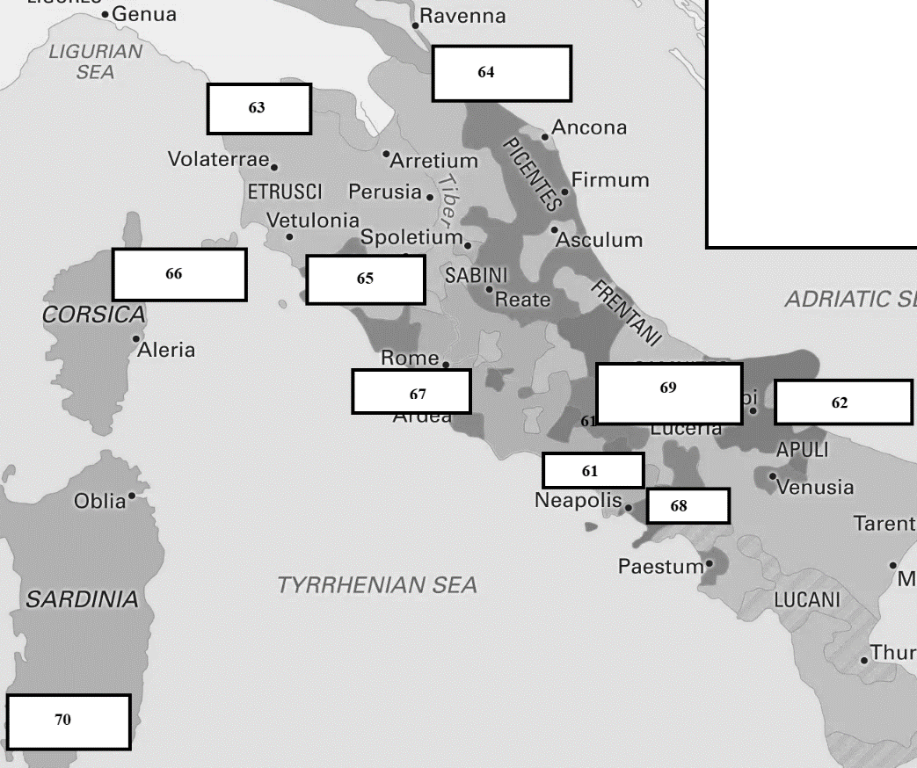

61. a.Capua b. Syracuse
c. Pisae d. Nola
62. a. Aesernia b. Sipontum
c. Mariana d. Ostia
63. a. Volsinii b. Capua
c. Nola d. Pisae
64. a. Sipontum b. Ariminum
c. Caralis d. Pisae
65. a. Capua b. Volsinii
c. Arminium d. Sipontum
66. a. Mariana b. Volsinii
c. Caralis d. Pisae
67. a. Nola b. Arminium
c. Ostia d. Ostia
68. a. Nola b. Ostia
c. Sipontum d. Caralis
69. a. Caralis b. Volsinii
c. Aesernia d. Pisae
70. a. Sipontum b. Aesernia
c. Caralis d. Mariana
.

ROMAN DAILY LIFE
Select the correct term for the definition:

71. A broad-billed felt hat
a. petasus b. pileus c. cucullus d. paenulum
72. Cloth ribbons used in a Roman woman’s hair
a. reticula b. taenia c. coronae d. nodi
73. The tray from which dishes were passed during dinner
a. ferculum b. tempestiva c. crater d. mensa
74.An empty tomb used in situations where the body could not be recovered for cremation
a. ustrina b. sepulchrum c. puticulus d. cenotaphium
75. knobs, occasionally gilded or painted, used at the end of the slip of wood in a papryrus roll
a. umbilici b. cornua c. frontes d. capsae
76. kiln-burnt bricks, often used as a facing for a Roman home
a. opera reticulata b. lateres cocti c. opera incerta d. fistucae
77. The share of cost incurred by a burial society
a. cultores b. collegia funeraticia c. sortes viriles d. collegia salutaria
78. Slide bolts used to secure the outer door of a Roman home
a. serae b. ostia c. aulaeae d. pessuli
79. Shutters around a window, often in two parts moving in opposite directions
a. iunctae b. fenestrae c. foriculae d. velae
80. Urns used to contain burial ashes
a. ollae b. tituli c. podia d. columbariae
READING PROSE
Select the best answer based on the following passage:

The excesses of Quartilla lead to an immoral suggestion

(1) Pōne eōs montēs ultrāque Aquilōnem gēns fēlīx, sī crēdimus, quōs Hyperboreōs appellāvēre, annōsō dēgit aevō, (2) fābulōsīs celebrāta mīrāculīs. ibi crēduntur esse cardinēs mundī extrēmīque sīderum ambitūs sēmēnstrī lūce [et
(3) ūnā diē] sōlis adversī, nōn, ut imperītī dīxēre, ab aequinoctiō vernō in autmnum: semel in annō sōlstitiō oriuntur (4) iīs sōlēs brūmāque semel occīdunt. regiō aprīca, fēlīcī temperiē, omnī adflātū noxiō cārēns. domus iīs nemora
(5) lūcīque, et deōrum cūtus virītim gregātimque, discordia ignōta et aegritūdō omnis. mors nōn nisi satietāte vītae
(6) epulātīs dēlibūtōque seniō luxū ē quādam rūpe in mare salientibus; hoc genus sepultūrae beātissimum.

Plinius Maior Natvralis Historiae Liber IV.89

81. According to the passage, where do the Hyperboreans live?
A) far to the west B) far to the north C) Far to the east D) far to the south

82. How long is the period of continuous daylight experienced by the Hyperboreans?
A) 12 months B) 6 months C) 3 months D) 1 month

83. When do the suns rise for the Hyperboreans, according to the passage?
A) At the vernal equinox B) At the autumnal equinox
C) At the summer solstice D) At the winter solstice

84. What is the significance of the summer solstice for the Hyperboreans?
A) It marks the end of their year. B) It brings continuous darkness.
C) It's when the sun rises. D) It's a time of extreme cold.

85. How does the sun behave in the region of the Hyperboreans during the winter solstice?
A) It sets only briefly and rises again. B) It remains hidden throughout the day.
C) It sets for a long period. D) It becomes extremely hot.

86. What are the supposed geographical features beyond the mountains where the Hyperboreans live?
A) Hinges upon which the world revolves B) Vernal equinox and autumn
C) Noxious blasts D) A hidden treasure

87. How is the climate described in the region of the Hyperboreans?
A) Extremely hot B) Cold and harsh C) Delightful temperature D) Constant darkness

88. What is the central idea of the passage?
A) The mystery of the vernal equinox B) The changing seasons in different regions
C) The remarkable life of the Hyperboreans D) The scientific explanation of the sun's movement

89. According to the passage, what is a common misconception about the sun's behavior in the Hyperborean region?
A) The sun rises every day. B) The sun never rises at all.
C) The sun sets at the vernal equinox. D) The sun hides during the summer solstice.

90. According to the passage, how do the Hyperboreans view death?
A) As a natural part of life B) As a result of old age and indulgence
C) As a form of sacrifice D) As a terrifying event

READING POETRY

vix tamen ēripiam, positō pāvōne vēlīs quīn
hoc potius quam gallīna tergere palātum,
corruptus vānīs rērum, quia veneat aurō 25
rāra avis et picta pandat spectācula cauda:
tamquam ad rem attineat quidquam. num vēsceris ista,
quam laudās, plūmā? coctō num adest honor īdem?
carne tamen quamvīs distat nīl, hāc magis illam
inparibus fōrmīs dēceptum tē petere estō: 30
unde datum sentīs, lupus hic Tiberīnus an altō
captus hiet? pontīsne inter iactātūs an amnīs
ōstia sub Tuscī? laudās, īnsāne, trilībrem
mullum, in singula quem minuās pulmenta necesse est. 34
Q. Horati Flacci Sermonvm Liber Secvndvs

91. What is the subject of the speaker's discussion in the passage?
A) Kissing a palate B) The issues with gourmet eating
C) The cost of rare birds D) The beauty of ornate tails

92. What does the speaker suggest is the reason for preferring a peacock over a pullet?
A) The pullet is less tasty. B) The peacock is cheaper.
C) The pullet has more beautiful feathers. D) The peacock's appearance is more appealing.

93. According to the speaker, what do people admire about the rare bird's tail?
A) Its color B) Its texture C) Its spread D) Its meat

94. What does the speaker question about the admiration for the peacock's tail?
A) Whether it is too expensive B) Whether it is a vain show
C) Whether it is healthy to eat D) Whether it is a rare bird

95. What does the speaker wonder about the beauty of the peacock's tail when it's cooked?
A) Whether it retains its beauty B) Whether it becomes even more beautiful
C) Whether it becomes inedible D) Whether it changes color

96. What point does the speaker make about the meat of the two birds?
A) It is more expensive in the peacock. B) It is different between the two.
C) It is tastier in the pullet. D) It is not worth eating.

97. Why does the speaker find it deceiving to prefer the peacock over the pullet?
A) Because the peacock's tail is less beautiful. B) Because the peacock is a rare bird.
C) Because the two birds have the same meat. D) Because the pullet is more expensive.

98. In the passage, what does the speaker challenge the listener to determine?
A) The source of the pike they are eating. B) The weight of the mullet they are praising.
C) The location where the pike was caught. D) The type of feathers the peacock has.

99. What can be inferred about the pike mentioned in the passage?
A) It is being praised for its appearance. B) It is being prepared for a special occasion.
C) It was caught in different locations. D) It is a rare and expensive fish.

100. What does the speaker imply in lines 33-4 (laudās…est)?
A) The mullet is too heavy to carry.
B) The mullet is not as tasty as it seems.
C) Praising food is a wasteful habit.
D) Praising something for its appearance alone is impractical.

